University of Ulster

COM 353 Dynamic Web Authoring

Cheval Residences

**Report**

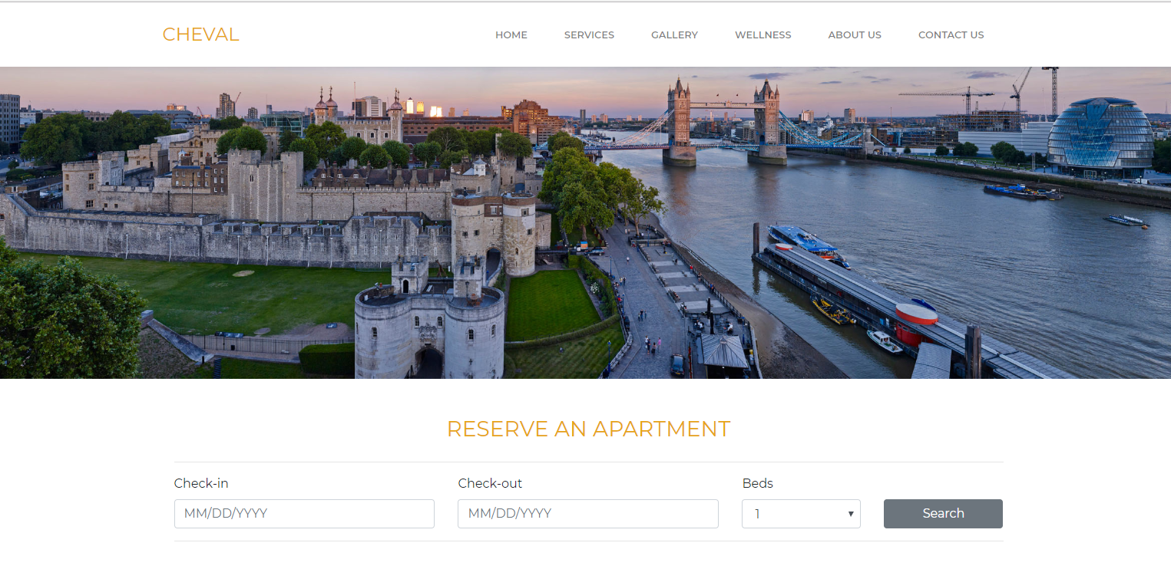

**Students Names:**

Radu Prajescu

Stoyan Stoyanov

Leo Groza

**Introduction**

The purpose of the group work has been to create a user-friendly dynamic and interactive website acting as a hotel booking webpage. The design of the website has been built in XHTML with CSS. In order to be up to date with the website design standards and to improve its learnability we have used a css library from Bootstrap. It is standard compliant, contains multiple pages and it can gather data supplied by the user. When accepting a user input the website provides the needed input validation to prevent from user mistakes. For the form validation and to calculate the final price of the stay we have used JavaScript. Without the JavaScript the website would not be dynamic.

In order to achieve a simple and clear design, the content of the website was divided between six pages: Home; Services, Gallery; Wellness; About us and Contact us. The ability to navigate freely in a multi-page website like this is an important part of the design. On the top of each page in the design a navigation bar is implemented which has the purpose to provide navigation links to other pages and documents. There is the logo of the hotel which acts as a home button on the left hand side and only six navigation links on the right hand side in order to reduce the short term memory load of the user.

**Design**

**Home**

On the main page we have the Room searching form where the user can choose the the check-in and check-out days of his stay and also the type of the room he would like to stay in. The form provides a date validation if the check-out date chosen is after the check-in date. Accordingly to the input, there will be three price suggestions for a Superior, Luxury and a Deluxe bedroom. Then by clicking on the book apartment button the customer is asked to fill up a multi-step modal form in order to complete the booking. The website provides data validation and error messages for all the user input of the form (Name, email, phone number, banking details, etc.). Before completing the booking the final price of the stay will be calculated in accordance to the length of the stay. At the end the modal provides a message for successful booking.

On the homepage, underneath the form, the website provides short welcoming message to the users and information about the hotel. There are also three cards with an image, information and a non-functional button just before the footer.

At the bottom of every page is a footer providing links to the other pages and and the names of the members of the group including a copyright statement at the end.

**Services, Gallery, Wellness, About us, Contact us**

Services, Gallery, Wellness and About us are static pages with clear design. They provide the user with information about the hotel and the services that it provides. On the Gallery page the user can scroll through the images using the buttons from the left and right side of the image or simply by using the arrow keys on the keyboard. And the Contact us page includes a form which the user can use in order to leave a comment, ask for assistance or leave a complaint.

Keeping things simple improves the User experience from usability point of use. These pages are with clean and minimalistic design. They attract the user’s attention to the information, rather than distracting with unnecessary content.